Hypothesis Testing
Definition of terms
- Independent variable is the variable the experimenter manipulates or changes, and is assumed to have a direct effect on the dependent variable.
- Dependent variable is the variable being tested and measured in an experiment, and is 'dependent' on the independent variable.
- Hypothesis is a precise, testable statement of what the researcher(s) predict will be the outcome of the study.
- Normal distribution is a continuous probability distribution that is symmetrical on both sides of the mean, so the right side of the center is a mirror image of the left side.
- Skewness is the degree of asymmetry observed in a probability distribution
- Z-score is a numerical measurement that describes a value's relationship to the mean of a group of values.
- Confidence interval refers to the probability that a population parameter will fall between a set of values for a certain proportion of times
- Significance level is the probability of rejecting the null hypothesis given that it is true
- p-value (probability value) is a number, calculated from a statistical test, that describes how likely you are to have found a particular set of observations if the null hypothesis were true.
- Null hypothesis is a statistical hypothesis that states that there is no relationship between two variables.
- Alternative hypothesis is the hypothesis that one adopts after rejection of null hypothesis
- Type I error refers to rejection of null hypothesis when the null hypothesis is true.
- Type II errors refers to retention of null hypothesis when it is false
- Power is the probability of correctly accepting the null hypothesis
- One-tailed test refers to when the given statistical hypothesis is one value like H₀: μ1 = μ2
- Two-tailed test refers to when the given statistics hypothesis assumes a less than or greater than value

Hypothesis
Hypothesis is a precise, testable statement of what the researcher(s) predict will be the outcome of the study. A hypothesis is an assumption about a population parameter that may or may not be true. This is the initial point of any investigation that translates the research questions into predictions. It includes components like variables, population and the relation between the variables. A research hypothesis is a hypothesis that is used to test the relationship between two or more variables.

Characteristics of Hypothesis
- The hypothesis should be clear and precise to consider it to be reliable.
- If the hypothesis is a relational hypothesis, then it should be stating the relationship between variables.
- The hypothesis must be specific and should have scope for conducting more tests.
- The way of explanation of the hypothesis must be very simple and it should also be understood that the simplicity of the hypothesis is not related to its significance.

Sources of Hypothesis
- The resemblance between the phenomenon.
- Observations from past studies, present-day experiences and from the competitors.
- Scientific theories.
- General patterns that influence the thinking process of people.

Types of Hypothesis
- Simple Hypothesis
It shows a relationship between one dependent variable and a single independent variable. For example – If you eat more vegetables, you will lose weight faster. Here, eating more vegetables is an independent variable, while losing weight is the dependent variable.
- Complex Hypothesis
It shows the relationship between two or more dependent variables and two or more independent variables. Eating more vegetables and fruits leads to weight loss, glowing skin, and reduces the risk of many diseases such as heart disease.
- Directional Hypothesis
It shows how a researcher is intellectual and committed to a particular outcome. The relationship between the variables can also predict its nature. For example- children aged four years eating proper food over a five-year period are having higher IQ levels than children not having a proper meal. This shows the effect and direction of the effect.
- Non-directional Hypothesis
It is used when there is no theory involved. It is a statement that a relationship exists between two variables, without predicting the exact nature (direction) of the relationship.
- Null Hypothesis
It provides a statement which is contrary to the hypothesis. It’s a negative statement, and there is no relationship between independent and dependent variables. The symbol is denoted by “HO”.
- Associative and Causal Hypothesis
Associative hypothesis occurs when there is a change in one variable resulting in a change in the other variable. Whereas the causal hypothesis proposes a cause-and-effect interaction between two or more variables.

Hypothesis testing
H₀: the null hypothesis
H_{a}: the alternate hypothesis

Null hypothesis: It is a statement about the population that either is believed to be true or is used to put forth an argument unless it can be shown to be incorrect beyond a reasonable doubt. It is also a statistical hypothesis that states that there is no relationship between two variables.
Null hypothesis is denoted by; H₀: μ1 = μ2, which shows that there is no difference between the two population means.

Alternative hypothesis is the hypothesis that one adopts after rejection of null hypothesis. It is also a statistical hypothesis that states that there is a relationship between two variables.
Alternative hypothesis is denoted H_{a}: μ1 ≠ μ2, it is contrary to the null hypothesis and shows that observations are the result of a real effect.

Null hypothesis (H₀)
- Represents the status quo.
- The hypothesis that states there is no statistical significance between two variables in the hypothesis.
- Believed to be true unless there is overwhelming evidence to the contrary.
- It is the hypothesis the researcher is trying to disprove.
Alternative hypothesis (H_{a})
- Inverse of the null hypothesis.
- States that there is a statistical significance between two variables.
- Holds true if the null hypothesis is rejected.

Examples of null and alternate hypothesis
Example 1
In a jury trial the hypotheses are:
H₀: defendant is innocent
H_{a} : defendant is guilty.
H₀ (innocent) is rejected if H_{a} (guilty) is supported by evidence beyond “reasonable doubt.”
Failure to reject H₀ (prove guilty) does not imply innocence, only that the evidence is insufficient to reject it.

Example 2
In testing blood pressure levels in diabetic and non-diabetic patients
H₀: There is no difference in blood pressure among diabetic and non-diabetic patients
H_{a} : There is difference between blood pressure among the diabetic patients and non-diabetic patient
There will be difference in blood pressure levels among diabetic and non-diabetic patients if the H₀ will be rejected and H_{a} is adopted

Steps of Hypothesis Testing
All hypotheses are tested using a four-step process:
- The first step is for the analyst to state the two hypotheses so that only one can be right.
- The next step is to formulate an analysis plan, which outlines how the data will be evaluated.
- The third step is to carry out the plan and physically analyze the sample data.
- The fourth and final step is to analyze the results and either reject the null hypothesis, or retain the null hypothesis if the data is true.

Types hypothesis testing
- Confidence interval
- Significance level
- p value

Hypothesis Testing via confidence interval (CI)
Using a given confidence interval (90%, 95% and 99%) we can reject or retain a null hypothesis. For instance, if we have intervals span from 2.7 to 3.7 and the null value µ=3 (95% CI). And the interval says any value within this range could conceivably be the true population mean therefore we cannot reject the null hypothesis in favor of the alternative.
- Since H₀: µ = 3 and H_{a}: µ > 3

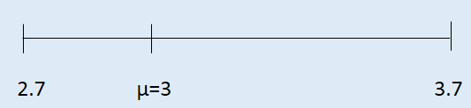
However, it doesn’t tell us the likelihood of certain outcome under the null hypothesis. In the other words it does not tell us the p value.
Hypothesis testing using significance level
The significance level, also denoted as alpha or α (like 0.05 or 0.1 at confidence level of 95% and 99% respectively), is a measure of the strength of the evidence that must be present in your sample before you will reject the null hypothesis and conclude that the effect is statistically significant. The researcher determines the significance level before conducting the experiment. In statistical tests, statistical significance is determined by citing an alpha level, or the probability of rejecting the null hypothesis when the null hypothesis is true. For this example, alpha, or significance level, is set at 0.01 (1%), 0.05 (5%), or 0.1 (10%). For example, a significance level of 0.05 indicates a 5% risk of concluding that a difference exists when there is no actual difference, whereas significance level of 0.01 indicates a 1% risk of concluding that a difference exists when there is no actual difference.

To calculate t-value, we use the formula below:

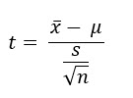

Where: x̄ is the sample mean,
μ is the population mean
s is the sample standard deviation
n is the number of observations in the sample.

Example: The sample mean (75 inches), the sample standard deviation (9.3 inches), and the number of observations in the sample (9) are all known. Assume the average height of students in the school is 69 inches, calculate t-value.
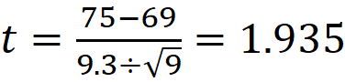
The calculated t-value can be used to test the original hypotheses and determine statistical significance. The first step is to look at a t-table and find the value (t-tabulated value) associated with degrees of freedom (df) of 8 (sample size - 1; 9-1 = 8) and our alpha level of 0.05. Because the test determines statistical difference between sample mean (class) and population mean (class), this is considered a two-tailed test. For this reason, the alpha level is divided in half (0.05/2 = 0.025) and then located on the t-table to find our critical value, which comes out to be 2.306.
Lower significance levels indicate that you require stronger evidence before you will reject the null hypothesis. Because the t-calculated value is lower than the critical value on the t-table (t-tabulation), we fail to reject the null hypothesis that the sample mean and population mean are statistically different at the 0.05 significance level. This means that the sample mean was obtained from the population mean 69 inches.
If t-value (t-calculated) is higher than the critical value (t-tabulated) in the table we reject the null hypothesis at significance level of 0.05.
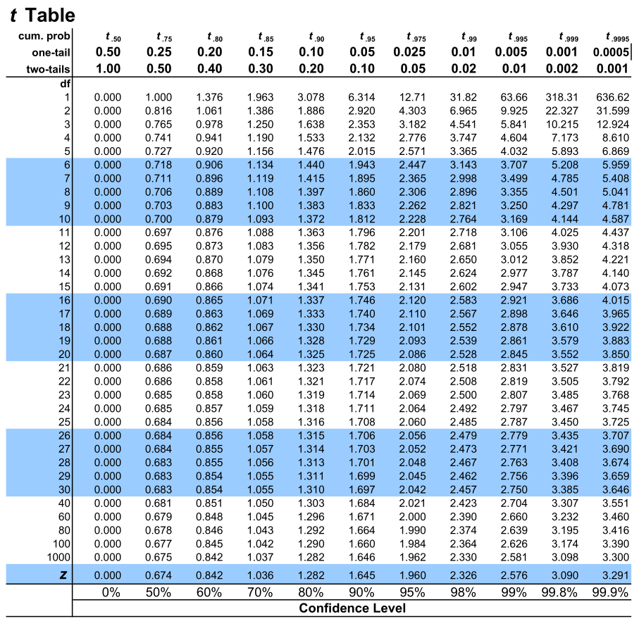
t distribution table
Hypothesis testing via p-value
- The p-value is a way of quantifying the strength of the evidence against the null hypothesis and in favor of the alternative. We use the test statistic to calculate the p-value, the probability of observing data at least as favorable to the alternative hypothesis as our current data, if the null hypothesis was true.
- If the p-value is low (lower than the significance level, α, which is usually 5 %) we say that it would be very unlikely to observe the data if the null hypothesis were true, and hence reject H₀.
- If the p-value is high (higher than α) we say that it is likely to observe the data even if the null hypothesis were true, and hence do not reject H₀.
- When a calculated p-value of 0.209 is higher than 0.05 (95% CI), we do not reject the null hypothesis. This is because the null hypothesis state that there is no significant difference (p>0.05) and the calculated p-value is greater than 0.05 (p=0.209), represent no significance difference. Therefore, we fail to reject the null hypothesis.
- When a calculated p-value of 0.04 is lower than 0.05 (95% CI), we reject the null hypothesis. This is because the p value is lower than the set significance level of 0.05, signifying there was significance difference (p<0.05). Thus, were reject the null hypothesis and adopt alternative hypothesis since null hypothesis state that there is no significant difference (p>0.05), whereas the alternative hypothesis state that there is significant difference (p≤0.05).
- p≤0.05 represent significant difference.
- p>0.05 represent no significant difference.
- Null hypothesis represents no significant difference between variables (p>0.05).
- Alternate hypothesis represents significant difference (p≤0.05).

Type I and Type II errors
- Type I error is the rejection of a true null hypothesis (also known as a "false positive" finding or conclusion; example: "an innocent person is convicted") or the test result says you have coronavirus, but you actually don’t.
- Type II error is the retention of a false null hypothesis (also known as a "false negative" finding or conclusion; example: "a guilty person is not convicted") or the test result says you don’t have coronavirus, but you actually do.
- Power of the test is the decision to reject H₀ when H₀ is false (correct decision).
- Each of the errors occurs with a particular probability. The Greek letters α and β represent the probabilities.
- α = probability of a Type I error = p(Type I error) = probability of rejecting a true null hypothesis
- β = probability of a Type II error = p(Type II error) = probability of retaining a false null hypothesis
- α and β should be as small as possible because they are probabilities of errors. They are rarely zero.
- The Power of the Test is 1 – β. Ideally, we want a high power that is as close to one as possible. Increasing the sample size can increase the Power of the Test.
- Power is the extent to which a test can correctly detect a real effect when there is one. A power level of 80% or higher is usually considered acceptable.
- The risk of a Type II error is inversely related to the statistical power of a study. The higher the statistical power, the lower the probability of making a Type II error.
- To reduce the Type I error probability, you can simply set a lower significance level. For example, from 0.05 to 0.01.
- To (indirectly) reduce the risk of a Type II error, you can increase the sample size or the significance level. Increasing the statistical power of your test directly decreases the risk of making a Type II error.

Statistical power is determined by:
- Size of the effect: larger effects are more easily detected.
- Measurement error: Systematic and random errors in recorded data reduce power.
- Sample size: larger samples reduce sampling error and increase power.
- Significance level: Increasing the significance level increases power (increase of significance level from 90% to 95%; or from 95% to 99%).

Trade-off between Type I and Type II errors
The Type I and Type II error rates influence each other. That’s because the significance level (the Type I error rate) affects statistical power, which is inversely related to the Type II error rate. This means there’s an important tradeoff between Type I and Type II errors:
- Setting a lower significance level decreases a Type I error risk, but increases a Type II error risk.
- Increasing the power of a test decreases a Type II error risk, but increases a Type I error risk.
Is a Type I or Type II error worse?
For statisticians, a Type I error is usually worse. In practical terms, however, either type of error could be worse depending on your research context.
A Type I error means mistakenly going against the main statistical assumption of a null hypothesis. This may lead to new policies, practices or treatments that are inadequate or a waste of resources.

Comparison between type I and type II errors
Decision | Reality
Decision | H₀ is true | H₀ is false
Reject H₀, (conclude H_{a}) | Type I error | Correct decision
Fail to reject H₀ | Correct decision | Type II error

Inferential statistics
Inferential statistics is a branch of statistics that makes the use of various analytical tools to draw inferences about the population data from sample data. Inferential statistics helps to draw conclusions about population data by analyzing the samples data obtained from it. It helps in making generalizations about the population by using various analytical tests and tools. There are two main types of inferential statistics- hypothesis testing and regression analysis. The samples chosen in inferential statistics need to be representative of the entire population.

Types of Inferential Statistics
Inferential statistics can be classified into hypothesis testing and regression analysis. Hypothesis testing also includes the use of confidence intervals to test the parameters of a population. Given below are the different types of inferential statistics.
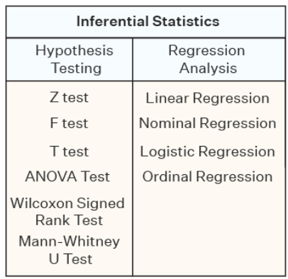
Hypothesis testing
Hypothesis testing is a type of inferential statistics that is used to test assumptions and draw conclusions about the population from the available sample data. It involves setting up a null hypothesis and an alternative hypothesis followed by conducting a statistical test of significance. A conclusion is drawn based on the value of the test statistic, the critical value, and the confidence intervals. A hypothesis test can be one tail (left-tailed, right-tailed), and two-tailed. Given below are certain important hypothesis tests that are used in inferential statistics.

Regression Analysis
Regression analysis is used to quantify how one variable will change with respect to another variable. There are many types of regressions available such as simple linear, multiple linear, nominal, logistic, and ordinal regression. The most commonly used regression in inferential statistics is linear regression. Linear regression checks the effect of a unit change of the independent variable in the dependent variable.

Grouping of Inferential statistical tests
Inferential statistical are categorized into two:
- Parametric
- Non-parametric
Both parametric and nonparametric tests can be used to evaluate hypotheses, and choice of which procedure to use depends on the type of variable analyzed and its characteristics.

Parametric
Parametric test are those tests both assume that the population data has a normal distribution. They include statistical tools like ANOVA, t-test, regression, correlation. One must compute for data normality before proceeding to analysis.
Normality tests include kurtosis (-2.99 to +2.99), skewness (-2.99 to +2.99, Kolmogorov–Smirnov (p>0.05), Shapiro Wilk (p>0.05), tests, including histograms (observe normality) and Q-Q plots.

Non-parametric
Non-parametric test are those tests that do not assume that the data is normally distributed. They include Chi square, Kruskal Willis, Mann-Whitney tests,

Parametric vs non-parametric tests
Parametric | Non-parametric
Used mainly on interval and ratio scale data | Used on ordinal and nominal data (although sometimes in interval and ratio scale if data is not normally distributed)
Need large sample size | Can be used on small samples
Used on normally distributed data | Used on data that is not normally distributed
Samples must be drawn randomly from the population | Can be used where samples are not selected randomly
Have more power than the non-parametric | Have less power than parametric
Uses continuous data | Uses categorical data or continuous data when it is not normally distributed

Non-parametric and parametric alternative
NONPARAMETRIC TEST | PARAMETRIC ALTERNATIVE
1-sample sign test | One sample Z-test, One sample t-test
1-sample Wilcoxon Signed Rank test | One sample Z-test, One sample t-test
Freidman test | Two-way ANOVA
Kruskal-Wallis test | One-way ANOVA
Mann-Whitney test | Independent sample t-test
Mood’s Median test | One-way ANOVA
Spearman Rank Correlation | Correlation Coefficient

Inferential statistical analysis
The use of statistical tests, either to test for significant relationships among variables or to find statistical support for the hypotheses. Inferential Statistics are numerical values that enable the researcher to draw conclusion about a population based on the characteristics of a population sample. This is based on the laws of probability. Level of Significance, an important factor in determining the representativeness of the sample population and the degree to which the chance affects the findings. The level of significance is a numerical value selected by the researcher before data collection to indicate the probability of erroneous findings being accepted as true. This value is represented typically as 0.01 (99%) or 0.05 (95%).

Hypothesis testing in inferential analysis
Steps in testing hypothesis:
- Determine the test statistics to be used
- Establish the level of significance
- Select a one-tailed or two-tailed test
- Compute a test statistic
- Calculate the degrees of freedom
- Obtain a tabled value for statistical test
- Compare the test statistics to the tabled value
- The outcome of the study perhaps may retain, revise or reject the hypothesis and this determines the acceptability of hypotheses
- If a p value is set at 0.05. It means that statistical significance will be ≤0.05. Therefore is an analysis is made and a p value of 0.67 is obtained, then one will fail to reject the null hypothesis. However, if a p value of 0.04 is obtained, the one will reject the null hypothesis in favor of the alternate hypothesis. This is because there is enough evidence to reject the null hypothesis.

Important statistical test for inferential analysis
- t-test (Student t-test)
A t-test is a statistical test that is used to compare the means of two groups. It is also referred as hypothesis test in which the test statistic follows a Student’s t-distribution. It is used to check whether two data sets are significantly different from each other using means. It cannot be used when one has more than two sample. It assesses whether the mean of a group of scores is statistically different from the population (One sample t test). Besides, it assesses whether the means of two groups of scores are statistically different from each other (Two sample t test).

Types of t-test
Type of t-Test | Details
One-sample t-test | It assesses if the mean of one sample is significantly different than the population mean.
Paired t-test | It assesses if the means of a pair of related samples are significantly different or not.
Two-sample (independent) t-test | It assesses if the population means of two independent (unrelated) samples are significantly different or not

Assumptions of t-test
- Data values are continuous.
- Simple random sampling
- Data must have normal distribution (bell shape)
- Adequacy of sample size
- Homogeneity of variance. Homogeneous, or equal, variance exists when the standard deviations of samples are approximately equal. Tested using Levene’s test

One sample t-test
- One of the variants of the t-test is the one-sample t-test which is used to determine if the sample is significantly different from the population.
- The formula for a one-sample t-test is expressed using the observed sample mean, the theoretical population means, sample standard deviation, and sample size.
- Mathematically, it is represented as;
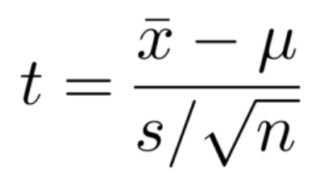
Where;
x̄ = Observed Mean of the Sample
μ = Theoretical Mean of the Population
S = Standard Deviation of the Sample
n = Sample Size

Example
Let us take the example of biostatistics students that appeared for a test recently. A sample of 10 students was chosen from a total of 150 students. Calculate the sample’s t-test score if the mean score of the entire class is 68 and the mean score of the sample is 75 with a standard deviation of 3.5. Also, comment on whether the sample statistics are significantly different from the population at a 95% confidence interval.

t = ( x̄ – μ) / (S / √n)

t = (75 – 68) / (3.5 / √10)
t = 6.36

When both the test statistic and the critical t-score are calculated, the two values are compared. If the test statistic is greater than the critical t-score, then the difference in means between samples is statistically significant.

The t- critical value (t-tabulated) is obtained from the t-distribution table using confidence level of 95% (significance level 5%, p value 0.05) and degree of freedom of 9 (n-1= 10-1=9).

The sample’s t-test value is 6.36, which is greater the critical t value (2.262) at a 95% confidence interval with a degree of freedom of 9. So, the hypothesis of the sample statistic is different than the population and can be rejected. These means that the sample mean is significantly different than the population mean.

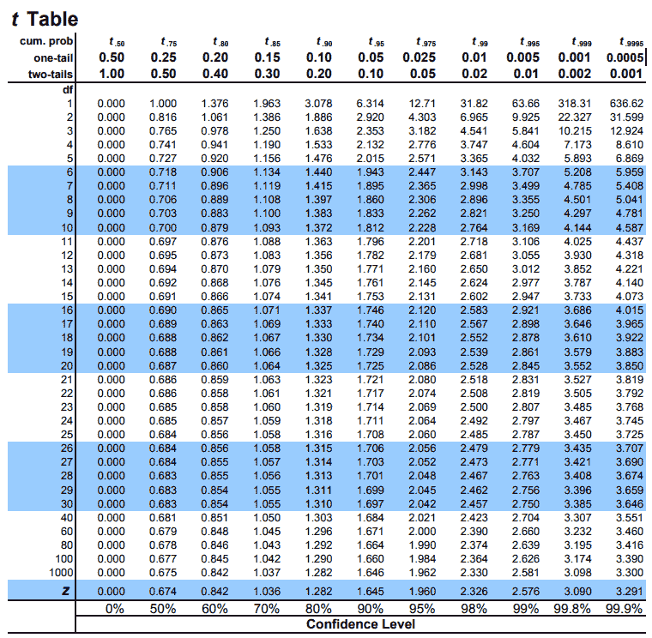

t-Test for Paired Samples
Paired t-test, is used to find out whether or not the means of a pair of related samples are significantly different. Related samples are samples that are taken from the same subject, such as before-and-after results. To conduct a paired t-test, it is necessary to know the sample mean of the differences, the sample standard deviation of the differences, and the sample size. The mean of the differences is calculated by subtracting the second sample from the first sample within each pair, then adding together each difference from all of the pairs and dividing them by the number of pairs.

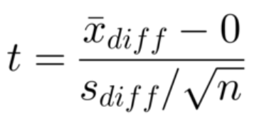

Where;
x̄diff is the sample mean of the differences
Sdiff is the sample standard deviation of the differences
n is the sample size.
Example
Perform a paired t-test for data with a sample mean of differences of 100, sample standard deviation of differences of 500, and sample size of 28. Use a significance level of α=0.05.
Substituting these values into the paired-sample t-score formula produces:

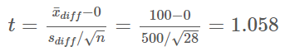

The degrees of freedom are defined as n−1, =28−1=27. Consulting a t- distribution table produces the critical t-score of 2.052. A comparison of the calculated test statistic and the critical t-score shows that 1.058<2.052. Thus, the difference in means of samples one and two is not statistically significant (the means are the same), since the t-calculated was less than t-tabulated.

t-test for Independent Samples
The t-test for independent samples, also known as a two-sample t-test, is used to find out whether or not the unknown population means of two groups are statistically similar given the two samples are independent and have normal distributions. To conduct a two-sample t-test, it is necessary to know if the sample variances are equal in both of the populations. When the two independent samples are assumed to be drawn from populations with identical population variances (i.e., σ12 = σ22)
The t-test equation for equal variances is:
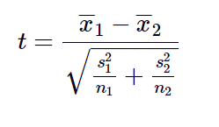

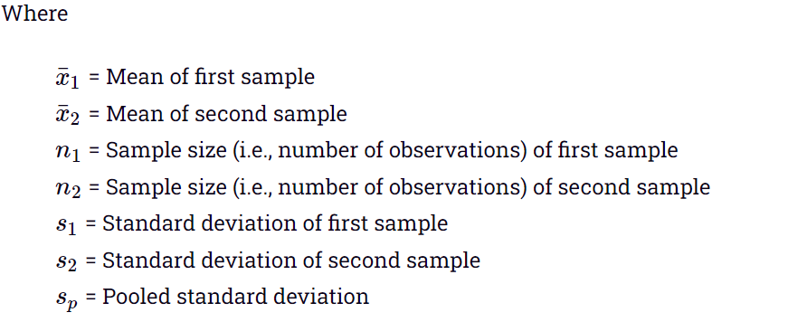

Example
20 calls are randomly selected from two call centers in terms of average call lengths. Is the average call length statistically significant at 95%?
Call Center A: Sample mean, x̄ 1 = 122 seconds, SD, S1 = 15 seconds, n1 = 20
Call Center B: Sample mean, x̄ 2 = 135 seconds, SD, S2 = 20 seconds, n2 = 20

Calculate homogeneity of variance first to check if the two samples have equal variance or not. If the variance are not equal use the method for the unequal variance. Homogeneity of variance is calculated as a ratio by is dividing the maximum variance with the minimum variance. The ratio is known as F ratio. Then, find the F-critical value (F tabulated) from the F-distribution table below (degree of freedom between groups (along the column) and degree of freedom within groups (along the column) of F-distribution table. Levene’s test can also be computed using statistical software’s (when p>0.05, the variance are equal).
The F ratio of this data = 400/225 =1.78 (F ratio). F table, F critical = 4.08 (df between group is 2-1= 1, df within groups column = n1 + n2 -2 = 20 + 20 – 2 = 38)
Since F-tabulated (4.08) is greater than F-ratio (1.78), we fail to reject null hypothesis (variance are equal, remember null hypothesis states that there is no significant difference between variables).

Then, calculate t using the above formula.

t=((135-122))/√((20×20/20)+(15×15/20))
t=13/√(31.25) = 2.3256
Degree of freedom, df = n1 + n2 -2 = 20 + 20 – 2 = 38
The critical value of a two-tailed t-test with df of 38 and level of significance as 0.05 is 2.021 from t-distribution table. Since the current t-value of 2.3256 is greater than the critical value of 2.021, we reject the null hypothesis that there is no statistical difference between the performance in terms of the call length time. Thus, based on the given evidence, the alternate hypothesis is adopted (There is difference between in terms of the call length time).

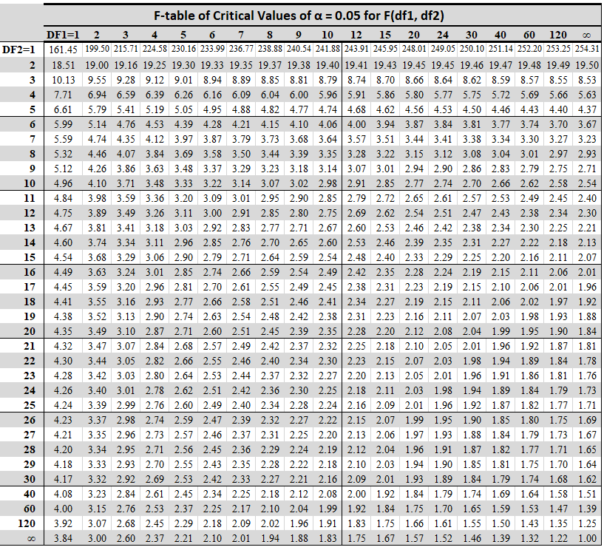
F distribution table
- Analysis of Variance (ANOVA).
It is used to test the significance of differences between means of three or more groups. Data set should be normally distributed. Before analysis data must be checked for normality. Levene’s test should be carried out to check for homogeneity of variance (p>0.05). The overall ANOVA test will indicate if a difference exists between any of the groups. However, the test will not specify which groups are different. A post hoc ANOVA test such as Tukey’s (Honest significant difference (HSD)), Fischer’s (Least significant difference (LSD)), Bonferroni (when sample size are not the same), Dunnett’s (use control to compare with other groups) and Scheffe’s post hoc test are used in case of significant difference among groups. Research hypothesis (Null hypothesis) will state that there are no significant difference between any of the groups.

Assumptions of ANOVA
- Continuous data/measured on scale
- Normal distributed data
- Have three or more independent sample groups
- Random sampling
- Homogeneity (homoscedasticity) of variance across all the samples. Homogeneity means that the variance among the groups should be approximately equal (p>0.05). One can compute F ratio by dividing the largest variance with the smallest variance, compare F-ratio to the F- distribution table. If F-ratio exceeds table value, variance are not equal

ANOVA Computations Table
 | SS | df | MS | F
Between (Model) | SS(B) | k-1 | SS(B)  k-1 | MS(B)  MS(W)
Within (Error) | SS(W) | n-k | SS(W)  N-k
Total | SS(W)+SS(B) | n-1

Key
SS = Sum squares
SS(B) = sum squares of sample groups
SS(W) = sum squares of sample size
df = degree of freedom
MS = mean square
n = sample size
k = number of sample groups

If the F calculated (statistic) is higher than the F probability table, reject the null hypothesis

Types of ANOVA
- One way ANOVA.
A one-way ANOVA evaluates the effect of a single factor (independent variable) on a single response variable (dependent variable). The one-way ANOVA is used to determine whether there are any statistically significant differences between the means of three or more independent (unrelated) groups. It determines whether all the samples are the same. For example, effect of gender (1 independent variable) on anxiety (one dependent variable) among university students. Blood sugars levels (one dependent) among diabetic patients (independent variable) in Kenya. The example given above is an example of one-way ANOVA.

- Two-way ANOVA (factorial ANOVA).
is an extension of the one-way ANOVA. It has two independent variables. It is utilized to determine the interaction between the two factors and tests the effect of two factors at the same time. For example, to understand whether there is an interaction between gender (1 independent variable) and educational level (2 independent variable) on anxiety (dependent variable) amongst university students. Another example, is comparing workers productivity based on two independent variables, such as salary and skill set.
- MANOVA (multivariate ANOVA) differs from ANOVA as the former tests for multiple dependent variables simultaneously while the latter assesses only one dependent variable at a time.

III. Chi-square (χ²)
A chi-square (χ²) statistic is a measure of the difference between the observed and expected frequencies of the outcomes of a set of events or variables. Chi-square is useful for analyzing differences in categorical variables, especially those nominal in nature like marital status or gender. χ² depends on the size of the difference between actual and observed values, the degrees of freedom, and the sample size. χ² can be used to test whether two variables are related or independent from one another. It can also be used to test the goodness-of-fit between an observed distribution and a theoretical distribution of frequencies.
Types of Chi-Square Statistic
There are two main kinds of chi-square tests:
- The test of independence, which asks a question of relationship, such as, "Is there a relationship between student gender and course choice?".
- The goodness-of-fit test, which asks something like "How well does the coin in my hand match a theoretically fair coin?

Assumptions of Chi square test
- Both variables are categorical
- All observations are independent.
- There are 2 variables, and both are measured as categories, usually at the nominal level.
- The data in the cells should be frequencies, or counts of cases rather than percentages or some other transformation of the data.
- Cells in the contingency table are mutually exclusive. It’s assumed that individuals can only belong to one cell in the contingency table. That is, cells in the table are mutually exclusive – an individual cannot belong to more than one cell.
- Expected value of cells should be 5 or greater in at least 80% of cells.

When to Use a Chi-Square Test
- A chi-square test is used to help determine if observed results are in line with expected results, and to rule out that observations are due to chance.
- A chi-square test is appropriate for data collected in a random sample, and when the variable in question is a categorical variable such as race, educational attainment, (gender) male or female.
- These types of data are often collected via survey responses or questionnaires. Therefore, chi-square analysis is often most useful in analyzing this type of data

How to Perform a Chi-Square Test
These are the basic steps whether you are performing a goodness of fit test or a test of independence:
- Create a table of the observed and expected frequencies
- Use the formula to calculate the chi-square value
- Calculate degree of freedom
- Find the critical chi-square value using a chi-square value table
- Determine whether the chi-square value or the critical value is the larger of the two
- Reject or accept the null hypothesis.
- If the chi square statistic exceeds the probability or table value (based upon a p-value of x and n degrees of freedom) the null hypothesis should be rejected.

Limitations of the Chi-Square Test
- The chi-square test is sensitive to sample size. Relationships may appear to be significant when they aren't simply because a very large sample is used.
- In addition, the chi-square test cannot establish whether one variable has a causal relationship with another. It can only establish whether two variables are related.

The Formula for Chi-Square Is
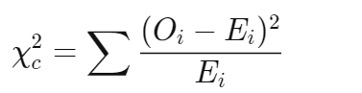
where:
c=Degrees of freedom
O=Observed value(s)
E=Expected value(s)

Example 2
The data below was obtained from a research study on cigarette smoking among male and female respondents residing in Nairobi County, Kenya. Calculate the Chi-square value of the data below. Also, draw conclusion from this study at significance level of 0.05

 | Gender
Cigarette smoking | Male | Female
Yes | 110 | 62
No | 82 | 130

The Formula for Chi-Square Is

where:
c=Degrees of freedom
O=Observed value(s)
E=Expected value(s)

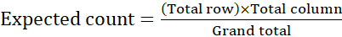

An expected count is the theoretically expected frequency of a cell, supposing that the groups under study are independent. To calculate an expected count for a cell in a table, compute the product of the Row Total and the Column Total for the row and column containing that cell, and then divide that computed product by the Grand Total.

 | Sample A | Sample B | Row total
Category A | a | b | a+b
Category B | d | e | d+e
Column total | a+d | b+e | a+b+c+d+e

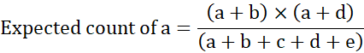

 | Gender |  | Total row
Cigarette smoking | Male | Female
Yes | 110 | 62 | 172
No | 82 | 130 | 212
Total column | 192 | 192 | 384

Calculated expected and all the values in the formula
Observed | Expected | O_{i} – E_{i} | (O_{i} – E_{i})² | (O_{i} – E_{i})²/Ei
110 | 86 | 24 | 576 | 6.70
62 | 106 | -44 | 1936 | 18.26
82 | 86 | -4 | 16 | 0.19
130 | 106 | 24 | 576 | 5.43
Total |  |  |  | 30.54

Chi square observed is 30.54

Obtain critical Chi square from Chi square distribution at α =0.05
df= (2-1)*(2-1) = 1
Critical Chi square =3.84

Since calculated/observed Chi square value, 30.54 is greater than critical Chi square value of 3.84, we reject the null hypothesis. Therefore, there is association between cigarette smoking and gender in Nairobi County, Kenya
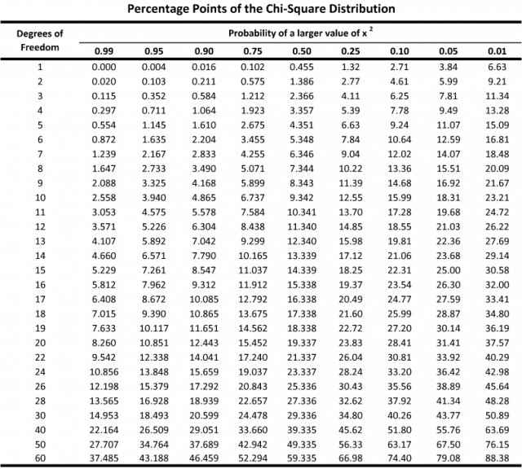

Interpreting the Chi Square Statistic
- The chi-square statistic tells you how much difference exists between the observed count in each table cell to the counts you would expect if there were no relationship at all in the population.
- A very small chi square test statistic means means there is a high correlation between the observed and expected values. Therefore, the sample data is a good fit for what would be expected in the general population. Therefore, the null hypothesis is retained.
- In theory, if the observed and expected values were equal (no difference) then the chi-square statistic would be zero — but this is unlikely to happen in real life.
- A very large chi square test statistic means that the sample data (observed values) does not fit the population data (expected values) very well. Therefore, we reject the null hypothesis.

IV Regression
A regression is a statistical technique that relates a dependent variable to one or more independent (explanatory) variables. While running a regression analysis, the main purpose of the researcher is to find out the relationship between the dependent and independent variables. One or multiple independent variables are chosen, which can help predict the dependent variable to predict the dependent variable. In addition, it helps validate whether the predictor variables are good enough to help predict the dependent variable. It does this by essentially fitting a best-fit line and seeing how the data is dispersed around this line. Regression captures the correlation between variables observed in a data set, and quantifies whether those correlations are statistically significant or not. For example, you might guess that there’s a connection between how much you eat and how much you weigh; regression analysis can help you quantify that.

A regression analysis formula tries to find the best fit line for the dependent variable with the help of the independent variables. The regression analysis equation is the same as the equation for a line which is:
y = bx+ a

Where,
y = the dependent variable
b= slope of the regression equation
x=independent variable
a = constant of the equation

Types of regression
- Linear regression
- Logistic Regression
- Ordinal Regression
- Polynomial Regression

Linear regression
Linear regression establishes the linear relationship between two variables based on a line of best fit. Linear regression is thus graphically depicted using a straight line with the slope defining how the change in one variable impacts a change in the other. The y-intercept of a linear regression relationship represents the value of one variable when the value of the other is zero. Non-linear regression models also exist, but are far more complex.

Assumptions of Linear Regression
- Homogeneity of variance (Homoscedasticity)
- Linear Relationships exist between the variables.
- Independent Sample observations.
- Normality: The data follows a normal distribution.
- Data collected randomly
- Continuous data

Types of linear regression

- Simple linear
- Multiple linear regression

Simple linear regression
Simple Linear Regression is a linear regression model with one independent and one dependent variable.
We denote simple linear regression by the following equation given below.
y = bx + a + e
Where:
y – variable that is dependent
x– Independent (explanatory) variable
a – Intercept
b – Slope
e – Residual (error)

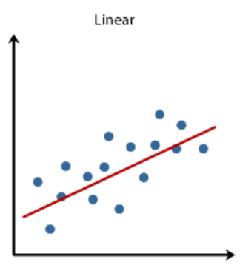
Example of linear regression
Interpretation of linear regression
Using the formula y = mx + b:
The linear regression interpretation of the slope coefficient, m, is, "The estimated change in y for a 1-unit increase of x."
The interpretation of the intercept parameter, b, is, "The estimated value of y when x equals 0."
The formula for intercept “a” and the slope “b” can be calculated per below.
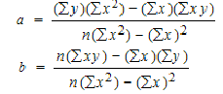

Example:
Calculate the linear regression equation of data below
Subject | Age x | Glucose Level y | xy | x² | y²
1 | 43 | 99 | 4257 | 1849 | 9801
2 | 21 | 65 | 1365 | 441 | 4225
3 | 25 | 79 | 1975 | 625 | 6241
4 | 42 | 75 | 3150 | 1764 | 5625
5 | 57 | 87 | 4959 | 3249 | 7569
6 | 59 | 81 | 4779 | 3481 | 6561
Σ | 247 | 486 | 20485 | 11409 | 40022
From the above table, Σx = 247, Σy = 486, Σxy = 20485, Σx2 = 11409, Σy2 = 40022. n=6.
Use the equations to find a and b.

Find a:
((486 × 11,409) – ((247 × 20,485)) / 6 (11,409) – 247²)
484979 / 7445
=65.14
Find b:
(6(20,485) – (247 × 486)) / (6 (11409) – 247²)
(122,910 – 120,042) / 68,454 – 247²
2,868 / 7,445
= 0.385225

Insert the values into the equation.
y = a + bx
y = 65.14 + .385225x

Explanation
- x here is an independent variable, and y is the dependent variable which changes with the change in the value of x by a certain value.
- 65.14 is the intercept which can be defined as the value which remains constant irrespective of the changes in the independent variable.
- 0.385225 in the equation is the slope of the linear regression, which defines how much of the variable is the dependent variable on the independent variable.

Multiple Linear Regression
It is a linear regression model with more than one independent variable and one dependent variable.
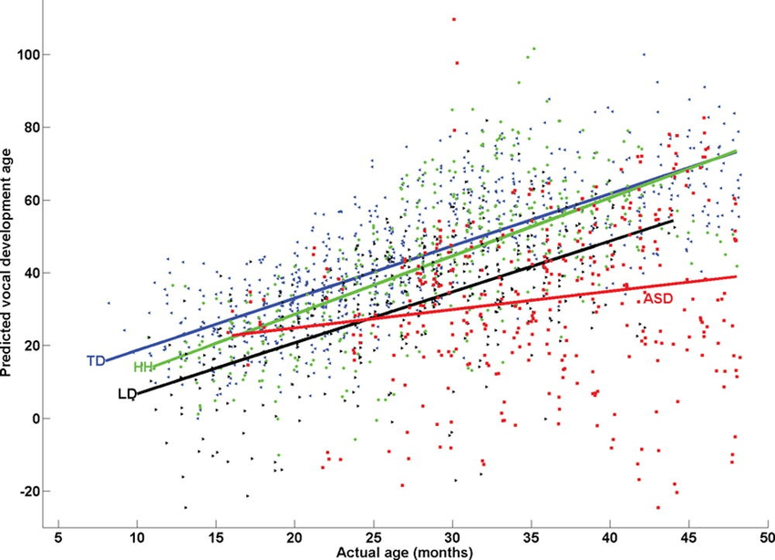
Example of multiple regression
Logistic regression
It is one of the types of regression analysis technique, which gets used when the dependent variable is discrete. Example: 0 or 1, true or false, etc. This means the target variable can have only two values, and a sigmoid curve denotes the relation between the target variable and the independent variable. Logit function is used in Logistic Regression to measure the relationship between the target variable and independent variables. Logistic regression is classified into binary, multinomial, and ordinal.

Ordinal Regression
Ordinal regression is used to foreshow ranked values. The technique is useful when the dependent variable is ordinal. Two examples of Ordinal regression are Ordered Logit and ordered probit.

Polynomial Regression
In a polynomial regression, the power of the independent variable is more than 1. The equation below represents a polynomial equation:

y = a + bx²

In this regression technique, the best fit line is not a straight line. It is rather a curve that fits into the data points.

V. Correlation
The degree of association is measured by a correlation coefficient, denoted by r. It is sometimes called Pearson’s correlation coefficient after its originator and is a measure of linear association. If a curved line is needed to express the relationship, other and more complicated measures of the correlation must be used.
The correlation coefficient is measured on a scale that varies from + 1 through 0 to – 1. There are three possible results of a correlational study: a positive correlation, a negative correlation, and no correlation.
A positive correlation is a relationship between two variables in which both variables move in the same direction. Therefore, when one variable increases as the other variable increases, or one variable decreases while the other decreases. An example of positive correlation would be height and weight. Taller people tend to be heavier.
A negative correlation is a relationship between two variables in which an increase in one variable is associated with a decrease in the other. An example of negative correlation would be height above sea level and temperature. As you climb the mountain (increase in height) it gets colder (decrease in temperature).
A zero correlation exists when there is no relationship between two variables. For example there is no relationship between the amount of tea drunk and level of intelligence.
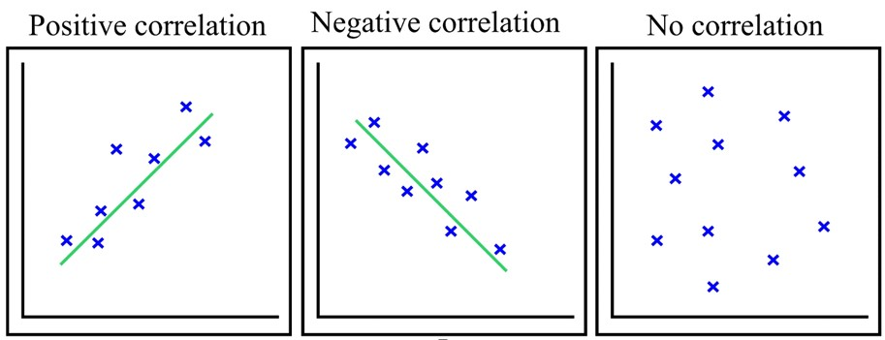

Mathematical formula for correlation
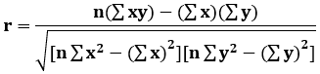
Where,
r = Pearson Coefficient
n= number of pairs
∑xy = sum of products of the pairs
∑x = sum of the x scores
∑y= sum of the y scores
∑x2 = sum of the squared x scores
∑y2 = sum of the squared y scores

Strength of correlation
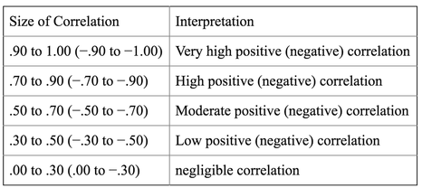

Analysis using software’s
Some of statistical software's used in data analysis include SPSS (Statistical Package for Social Science), R statistical software package, SAS (Statistical analysis Software), GraphPad Prism, Minitab, MatLab, Stata statistical software. Hypothesis testing using software’s result in accepting or rejecting the null hypothesis. A crucial step in null hypothesis testing is finding the likelihood of the sample result if the null hypothesis is true. The researcher needs to state a probability (p) value (p≤0.05). Criterion of rejecting the null hypothesis is called α (alpha) and is almost always set to 0.05. If analyzed p value is greater than the set p value of less or equal to 0.05, we fail to reject the null hypothesis. If the analyzed p value is less or equal to 0.05, we reject the null hypothesis in favor of alternate hypothesis.

Data Analysis, Interpretation and Presentation
Before Data Collection, the researcher should accomplish the following:
- Determine the method of data analysis
- Determine how to process the data
- Consult a statistician
- Prepare dummy tables
After Data Collection, the researcher should accomplish the following
- Process the data
- Prepare tables and graphs
- Analyze and interpret findings
- Consult again the statistician
- Prepare for editing
- Prepare for presentation

Steps in Data Analysis
- Ask the right question
Before you start collecting data, you need to first understand what you want to do with it. Take some time to think about a specific problem you want to address or consider a hypothesis that could be solved with data. From there, you’ll create a set of measurable, clear, and concise questions that will help answer that. Starting with a clear objective is an essential step in the data analysis process. By recognizing the problem that you want to solve and setting well-defined goals, it’ll be way easier to decide on the data you need.
- Data collection
Now that you have a solid idea of your questions, it’s time to define what data you need to find those answers. As a starting point, you’ll want to determine if the data is readily available. Then, ask yourself: do you have all the data you need or will you also need to externally source it? If it’s the latter, you may decide to run an experiment or conduct another survey. Whatever you choose, the end goal of this step is to make sure to have a complete view of the problem you want to solve.
- Data cleaning
After collecting data, raw data is not analyzed in its current form. Often raw data may have flaws within it, like missing values or outliers. Data cleaning, consists of amending or removing incorrect or superfluous data, as well as checking for incompleteness or inconsistencies. For instance, you might clean spaces in front of letters or symbols or remove duplicates. This is a vital step because ultimately, the accuracy of your analysis will depend on the quality of your data.
- Analyzing the data
You now have clean and organized data. In this step, you’ll begin to slice and dice your data to extract meaningful insights from it. Using the techniques and methods of data analysis, you’ll look for hidden patterns and relationships, and find insights and predictions. Data analysis can be done using software’s such as Statistical Package for Social Sciences (SPSS), Statistical Analysis Software (SAS), R statistical package, Minitab, GraphPad Prism among others.
- Interpreting the results
After you’ve interpreted the results and drawn meaningful insights from them, the next step is to create visualizations by selecting the most appropriate charts and graphs.
- Report research findings
The final step is to report the research findings to those who need the data to make decisions. The findings should be presented in a comprehensible format so that they can be readily used in the decision-making process. In addition, an oral presentation should be made to management using tables, figures, and graphs to enhance clarity and impact.

Classification of Data Analysis
- Data analysis can be classified into two:
- Descriptive Analysis
- Inferential Analysis
Descriptive Analysis
- Refers to the description of the data from a particular sample
- Descriptive statistics are numerical values obtained from the sample that gives meaning to the data collected.
- They summarize the data and describe sample characteristics.
Classification of descriptive statistics
- Frequency Distribution: A systematic arrangement of numeric values from the lowest to the highest
- Measure of Central Tendency: A statistical index that describes the average of the set values (e.g. Mean, median and mode).
- Measure of Variability: Statistics that concern the degree to which the scores in a distribution are different from or similar to each other. (e.g. range, variance, standard deviation).
- Bivariate Descriptive Statistics: Derived from the simultaneous analysis of two variables to examine the relationships between the variables (e.g. Contingency tables - is essentially a two-dimensional frequency distribution in which the frequencies of two variables are cross-tabulated and Correlation - the most common method of describing the relationship between two measures, negative correlation (-1), no correlation (0) and positive correlation (+1))
Example of contingency table of cigarette smoking by gender
Gender | Smoker | Non-smoker | Total
Male | 42 | 10 | 52
Female | 9 | 39 | 48
Total | 51 | 49 | 100
Presentation of Findings
- Findings are presented in different forms such as:
- Narrative or textual form: This is composed of summary of findings, direct quotations and implications of the study.
- Tables: Tables are used to present a clear and organized data.
- This is utilized for easy analysis and interpretation of data.
- Parts of table include: columns, row and cell
- Rows - horizontal entries (indicates the outcome or the dependent variable)
- Columns - vertical entries (indicates the cause or the independent variable)
- Cells - are boxes where rows and columns intersect.
- Graphical: A chart representing the quantitative variations. Example bar graphs, linear graphs, pie graphs, histograms, polygon, scatter plot.

Methods of Data Presentation
- Tables
Tables are a useful way to organize information using rows and columns. Tables are a versatile organization tool and can be used to communicate information on their own, or they can be used to accompany another data representation type such as graphs. Tables support a variety of parameters and can be used to keep track of frequencies, variable associations, and more. A table is good for organizing quantitative data in a way that it is easy to look things up. For example, a table would be good way to associate a person’s name, age, and favorite food. However, when trying to communicate relations, such as how a person’s favorite food changes over time, a graph would be a better choice.
To make a table, first decide how many rows and columns are needed to clearly display the data. To do this, consider how many variables are included in the data set.
Good practices for making tables
- Label what each row or column represents
- Include units in labels when data is numerical
- Format data consistently (use consistent units and formatting)

Example of a tables include ungrouped frequency distribution, grouped frequency distribution table, cumulative frequency distribution table, relative frequency distribution table.

Frequency Distribution Grouped in Intervals
Scores | Frequency (N = 12)
40 - 59 | 3
60 - 79 | 4
80 - 100 | 5

Advantages of tables
- A table facilitates representation of even large amounts.
- Easy to read.
- Well organized.

Disadvantages
- Does not give a good trend of data over time.

- Text
Textual presentation of data means presenting data in the form of words, sentences and paragraphs. When using textual presentation, use double open and closing quotation marks (“……….”) for the texts and then italicize them. The textual presentation of data is very helpful in presenting contextual data. It helps the researcher explain and analyze specific points in data.

Factors to consider when presenting data in textual
- The researcher should know the target audience who are going to read it. The researcher should use a language in the presentation of data that is easy to understand and highlights the main points of the data findings.
- The author should use wordings that does not introduce bias in research. Avoid the use of biased, slanted, or emotional language.
- Accuracy should be maintained in presenting data and the numbers and percentages presented in the textual data should be reviewed to avoid any mistakes in the presentation.
- To make it easier for the audience to comprehend the important points in data, the researcher should avoid unnecessary details.
- Do not repeat the same point again and again it will ruin the purpose of textual presentation. Your data presentation will become monotonous if there is repetition of data finding.
- Try to shorten longer phrases wherever possible, mix two phrases when they can be combined as one.
- One mistake that often researchers make is to use general descriptive words like, too much, little, exactly, all, always, never, must and many more.
- Another point to consider is to avoid decorative language while make sure that you use scholarly language in your data presentation.

- Pie chart
The “pie chart” is also known as a “circle chart”, dividing the circular statistical graphic into sectors or sections to illustrate the numerical problems. Each sector denotes a proportionate part of the whole. The sum of all the data is equal to 360°. Therefore, the pie chart formula is given as
(Given Data/Total value of Data) × 360°

Advantages of pie chart
- The picture is simple and easy-to-understand
- Data can be represented visually as a fractional part of a whole
- It helps in providing an effective communication tool for the even uninformed audience
- Provides a data comparison for the audience at a glance to give an immediate analysis or to quickly understand information
- No need for readers to examine or measure underlying numbers themselves, which can be removed by using this chart
- To emphasize a few points you want to make, you can manipulate pieces of data in the pie chart

Disadvantages pie chart
- It becomes less effective if there are too many pieces of data to use
- If there are too many pieces of data. Even if you add data labels and numbers may not help here, they themselves may become crowded and hard to read
- As this chart only represents one data set, you need a series to compare multiple sets
- This may make it more difficult for readers when it comes to analyze and assimilate information quickly

How to Create a Pie Chat
Imagine a teacher surveys her class on the basis of favourite Sports of students:
Football | Hockey | Cricket | Basketball | Badminton
10 | 5 | 5 | 10 | 10
The data above can be represented by a pie chart as following and by using the circle graph formula, i.e. the pie chart formula given below. It makes the size of the portion easy to understand.
Step 1: First, Enter the data into the table.
Football | Hockey | Cricket | Basketball | Badminton
10 | 5 | 5 | 10 | 10
Step 2: Add all the values in the table to get the total.
I.e. Total students are 40 in this case.
Step 3: Next, divide each value by the total and multiply by 100 to get a per cent:
Football | Hockey | Cricket | Basketball | Badminton
(10/40) × 100  =25% | (5/ 40) × 100  =12.5% | (5/40) ×100  =12.5% | (10/ 40) ×100  =25% | (10/40)× 100  =25%
Step 4: Next to know how many degrees for each “pie sector” we need, we will take a full circle of 360° and follow the calculations below:
The central angle of each component = (Value of each component/sum of values of all the components)✕360°
Football | Hockey | Cricket | Basketball | Badminton
(10/ 40)× 360°  =90° | (5 / 40) × 360°  =45° | (5/40) × 360°  =45° | (10/ 40)× 360°  =90° | (10/ 40) × 360°  =90°
Now you can draw a pie chart.
Step 5: Draw a circle and use the protractor to measure the degree of each sector.

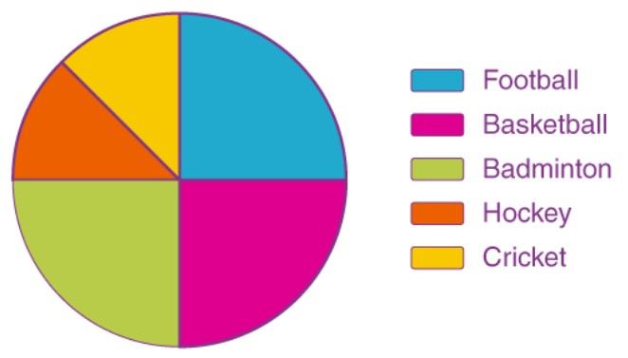
- Bar graph
A bar graph is a pictorial representation using vertical and horizontal bars in a graph. The length of bars are proportional to the measure of data. It is also called bar chart. The bars drawn are of uniform width, and the variable quantity is represented on one of the axes. Also, the measure of the variable is depicted on the other axes. The heights or the lengths of the bars denote the value of the variable, and these graphs are also used to compare certain quantities. The frequency distribution tables can be easily represented using bar charts which simplify the calculations and understanding of data. Bar graphs are used to match things between different groups or to trace changes over time.

Properties of Bar Graph
Some of the important properties of a bar graph are as follows:
- Have x and y axes.
- All the bars should have a common base.
- Each column in the bar graph should have equal width.
- The height of the bar should correspond to the data value.
- The distance between each bar should be the same.

Advantages of bar graphs:
- Bar graph summarizes the large set of data in simple visual form.
- It displays each category of data in the frequency distribution.
- It clarifies the trend of data better than the table.
- It helps in estimating the key values at a glance.

Disadvantages of bar graphs:
- Sometimes, the bar graph fails to reveal the patterns, cause, effects, etc.
- Cannot be used when groups of data are many.

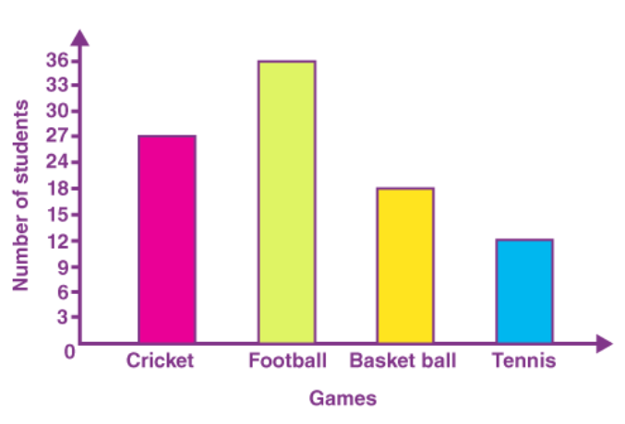
- Line graph
Line graph gives a graphical representation of the changes that had occurred over a given period of time. Line graph has a horizontal axis called the x-axis and a vertical axis called the y-axis. The x-axis usually has a time period over which we would like to measure the quantity of a specific thing or an item in the y-axis. Line graph helps to analyze the trend of whether the quantity in the y-axis is increasing or decreasing over a period of time. Line graph gives a clear picture of an increasing or a decreasing trend. All the data points are connected by a line.
Steps of construction of line graph:
- Draw two lines perpendicular to each other intersecting at O. The horizontal line is x-axis and vertical line is y-axis. Mark points at equal intervals along x-axis and write the names of the data items whose values are to be marked.
- Along the y-axis, choose an appropriate scale considering the given values.
- Now, make the points
- Join each point with the successive point using a ruler or a smooth curve

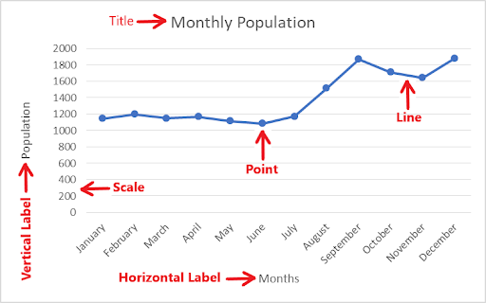

- Histogram
A histogram is also a pictorial representation of data using rectangular bars that are adjacent to each other. It is used to represent grouped frequency distribution with continuous classes. A histogram is a bar graph which shows frequency distribution.
How to Plot Histogram?
You need to follow the below steps to construct a histogram.
- Begin by marking the class intervals on the X-axis and frequencies on the Y-axis.
- The scales for both the axes have to be the same.
- Class intervals need to be exclusive.
- Draw rectangles with bases as class intervals and corresponding frequencies as heights.
- A rectangle is built on each class interval since the class limits are marked on the horizontal axis, and the frequencies are indicated on the vertical axis.
- The height of each rectangle is proportional to the corresponding class frequency if the intervals are equal.
- The area of every individual rectangle is proportional to the corresponding class frequency if the intervals are unequal.
Although histograms seem similar to graphs, there is a slight difference between them. The histogram does not involve any gaps between the two successive bars.

When to Use Histogram?
The histogram graph is used under certain conditions. They are:
- The data should be numerical.
- A histogram is used to check the shape of the data distribution.
- Used to check whether the process changes from one period to another.
- Used to determine whether the output is different when it involves two or more processes.
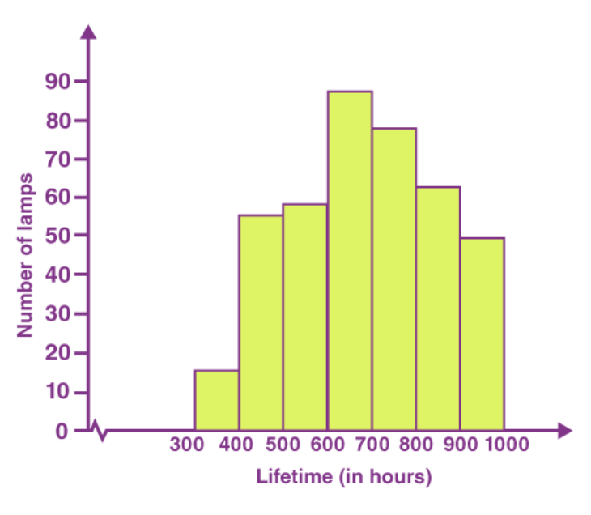
Differences between bar graph and histogram
Bar graph | Histogram
Bar graph is the graphical representation of categorical data | Bar graph is the graphical representation of grouped data in continuous manner
There is equal space between each pair of consecutive bars | There is no space between the consecutive bars
The height of the bars shows the frequency and the width gap is zero | The frequency of the data is shown by the area of rectangular bars

- Scatter plot
Scatter plots are the graphs that present the relationship between two variables in a data-set. It represents data points on a two-dimensional plane or on a Cartesian system. The independent variable or attribute is plotted on the x-axis, while the dependent variable is plotted on the y-xis.
Scatter plots are used in either of the following situations.
- When we have paired numerical data
- When there are multiple values of the dependent variable for a unique value of an independent variable
- In determining the relationship between variables in some scenarios, such as identifying potential root causes of problems, checking whether two products that appear to be related both occur with the exact cause and so on.

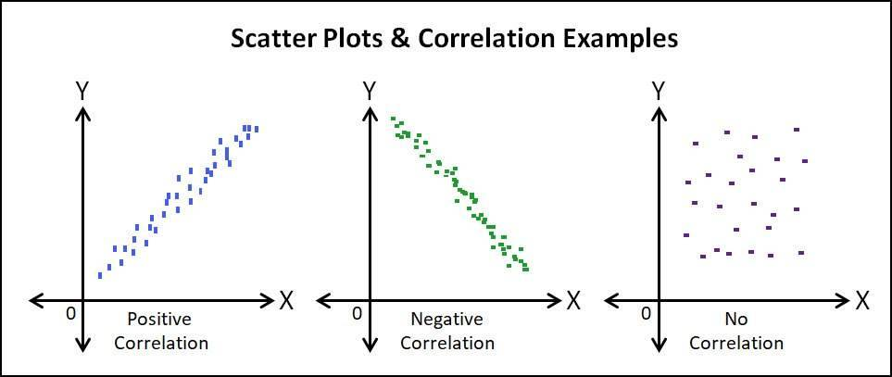

- Heat map
A heat map represents data density in colours. The bigger the number, the more colour intense that data will be represented.

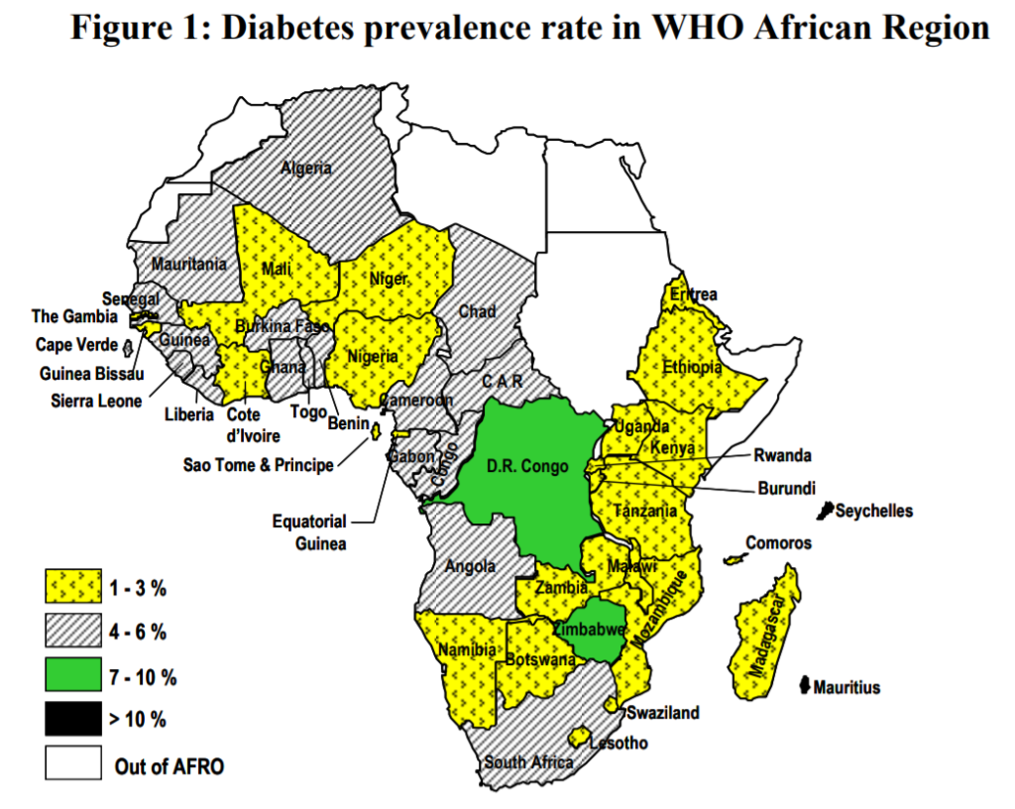

Interpretation of Data
- After analysis of data and the appropriate statistical procedure, the next chapter of the research paper is to present the interpretation of the data, which is the final step of research process.
- Make generalization or building theory. The process of interpretation may lead to new questions providing room for further research. Generalization is the extent the research and the conclusions of the research apply to the real world. The results should be reported in an objective and candid way. Any assumptions made in interpreting the results should be clearly identified. Limitations of the research should be discussed. Conclusions and recommendations should be stated as per objectives.
- The three areas:
- Summary of Findings
- Conclusions
- Recommendations

Summary of Findings
- This portion summarizes the result of data analysis
- The best thing is to review the stated problem and tie up with the result of your data analysis.
Conclusions
- A conclusion is drawn from the summary of findings.
- Focuses on the answers to the problem including the outcome of the hypotheses whether it is rejected or accepted.
Recommendations
- This is based on the result of the conclusions.
- The main goal is geared toward improvement or development.

The Format of Writing finding of a Study
- Preliminary Pages
- Title page/ Title of the Study - is a phrase that describes the research study. - It should not be too long or too short as well as too vague and general.
- Acknowledgement Page - is a section wherein the researcher expresses his deep gratitude for those persons who assisted and helped him to make the study a successful one.
- Table of Contents - from the word itself, it contains all the parts of the research paper including the pages.
- List of Tables - this follows the table of content and indicates the title of the tables in the research paper.
- List of Figures - is composed of paradigms, diagrams, graphs and charts or flowcharts.
- Abstract- a page brief summary of the study
- Main Body
- Chapter I: Introduction: Purpose is to introduce the reader to the subject matter. It also includes the statement of the problem, justification, significance of study, limitation and delimitation, main objectives and specific objective, hypothesis or research questions.
- Chapter II: Review of Related Literature
- Chapter III: Research Design and Methodology
- Chapter IV: Results (Analysis and Interpretation of Data)
- Chapter V. Discussion, Conclusions, and Recommendations

Supplementary Pages
Bibliography (references) and Appendix

Structure of the research paper/manuscript
- Abstract – Research problem, justification, objectives, methodology, results, conclusion, recommendations
- Introduction- What we know, gap of Knowledge filled by the study, justification and study objectives
- Methods - Study design (How?), Where?, When?, Population, Inclusion/Exclusion, Sampling, Sample size, Intervention/Condition being observed, Outcome measurement, Data collection, Data entry, Statistical analysis
- Results- reporting descriptive statistics, Univariate analysis, Bivariate analysis, Multivariate analysis, figures, charts, tables and captured images
- Discussion- Interpretation of result; Are results statistically significant?; What did previous studies concluded about this topic?; Is your study in accordance with previous studies; If not, justify this contradiction; Study strength points; Study limitations; Generalizability; Implications for future researchers; Final conclusion and recommendation
- Text Appendices
- References

Examples of peer reviewed journals
- BioMedical Central (BMC)
- Scopus
- Hindawi
- Elsevier
- Science direct
- Omics
- Molecules
- Frontiers

